**Enhancing Durability in Quarrying Operations with Abrasion Resistant Steel**

Quarrying and open-pit mining operations entail rigorous wear challenges that demand robust solutions. SSAB's Abrasion Resistant Steel emerges as a reliable choice, extending the service life of vital equipment components and minimizing the frequency of repairs and replacements throughout the production process.

**A. Hammer Mills: Crushing and Grinding with Resilience**

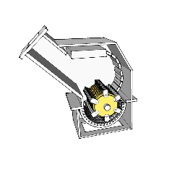

Hammer mills utilizes rotating hammers to crush and grind various materials. However, a significant challenge in operating hammer mills arises from the abrasion caused by the processed materials. The hammers and other vital components are in constant motion at high speeds, leading to wear and tear. Moreover, the operational environment further accelerates this wear, collectively reducing the mill's lifespan and resulting in expensive maintenance.

A practical solution to combat these issues lies in the use of abrasion-resistant steel. This robust material effectively addresses the challenges posed by hammer mill operations. It boasts strength and durability, allowing it to withstand the demanding conditions under which hammer mills function. Furthermore, its relative affordability makes it a cost-efficient method to extend the equipment's longevity. Abrasion-resistant steel proves especially valuable in fabricating essential hammer mill components like hammers, spacers, shafts, sieves, grizzly bars, and inner linings. Embracing abrasion-resistant steel empowers hammer mill operators to significantly elongate equipment lifespans and curtail the necessity for frequent repairs. Ultimately, this approach translates to substantial time and cost savings in the long term.

**Grades:** AR400 or AR500 steel can be used in hammer mills. These steel grades are known for their high strength and toughness, which can withstand the high impact forces generated by the hammer mill.

**B. Rotary and Impact Crushers: Elevating Aggregate Production**

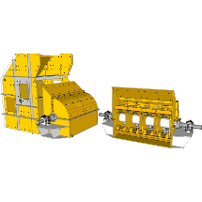

Rotary and impact crushers are machines designed to crush materials through either impact or compression, resulting in the reduction of materials into smaller fragments. These machines are particularly suited for processing robust materials like rocks and ores. However, this hardness factor can accelerate the wear and tear of crusher components. Complicating matters, the presence of wet materials can foster a corrosive environment that exacerbates the deterioration of these parts. When materials are both hard, abrasive, and wet, the risk of damage to crusher components escalates, leading to diminished operational efficiency, escalated maintenance expenses, and even potential equipment breakdowns.

To address these multifaceted challenges, the implementation of abrasion-resistant steel emerges as a practical solution. Recognized for its strength and durability, abrasion-resistant steel is engineered to endure the rigorous conditions inherent in crusher operations. Its relatively affordable cost adds to its appeal as a cost-effective means of prolonging the service life of crusher equipment.

Abrasion-resistant steel presents several advantages over conventional manganese castings, including:

**Elevated Hardness:** The inherent hardness of abrasion-resistant steel surpasses that of manganese castings, providing heightened resistance to abrasion.

**Enhanced Weldability**: Notably, abrasion-resistant steel is more amenable to welding compared to manganese castings, simplifying the repair process for damaged parts.

**Superior Performance**: Empirical evidence supports the superior performance of abrasion-resistant steel over manganese castings in the context of rotary and impact crushers.

Through the integration of abrasion-resistant steel in key components such as hammers, liners, and wear plates, rotary and impact crusher operators can extend the operational longevity of their machinery. This strategic upgrade not only prolongs the equipment's lifespan but also augments productivity while concurrently curbing maintenance expenditures.

**Grades:** AR400 or AR500 steel can also be used in rotary and impact crushers. These steel grades are also known for their high strength and toughness, which can withstand the high impact forces generated by these crushers.

**C. Enhanced Body Design: Reinventing Durability**

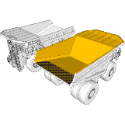

The durability of a dump truck greatly hinges on its body design, as this component continually endures the impact of transported materials and the abrasion from the motion of the dump bed during lifting and lowering. Specifically engineered to withstand wear and tear, abrasion-resistant steel is a preferred material for constructing dump truck bodies. Its implementation enhances body longevity, effectively diminishing the necessity for frequent repairs.

Among the varied wear types, dump truck bodies are particularly susceptible to sliding wear, which arises from the contact of two surfaces in motion. By incorporating abrasion-resistant steel, the likelihood of damage due to friction decreases, given the material's tougher and more enduring surface. Notably, abrasion-resistant steel boasts not only wear resistance but also several supplementary benefits:

1. Amplified strength and toughness.
2. Enhanced weldability.
3. Reduced weight.

These attributes collectively bolster the dump truck body's durability, fortifying it against impacts, heavy loads, and external forces. Through the integration of abrasion-resistant steel, manufacturers can engineer dump trucks with extended lifespans, leading to cost-effective operations. This translates to diminished maintenance expenses and heightened operational uptime, ultimately contributing to enhanced business profitability.

Furthermore, alongside the utilization of abrasion-resistant steel, manufacturers can further enhance dump truck body durability by streamlining designs and minimizing reinforcements. These strategies lighten the body, facilitating easier lifting and lowering actions, while simultaneously diminishing wear and tear. Embracing these measures empowers manufacturers to fashion dump truck bodies distinguished by their enduring nature, a quality that distinctly benefits businesses across multiple dimensions.

**Grades:** AR400 or AR500 steel can be used to enhance the durability of the body design. These steel grades are known for their high strength and toughness, which can withstand the harsh conditions of operation.

**D. Cone Crushers: Optimizing Crushing Efficiency**

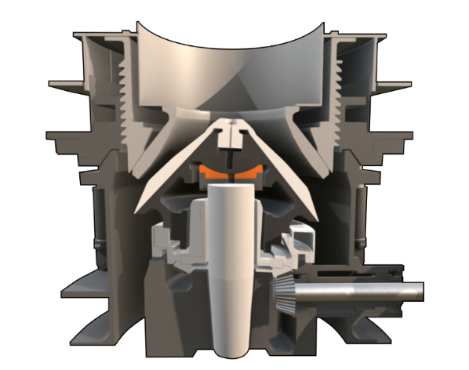

The longevity of a cone crusher's operational life is influenced by several factors. Among these are the nature of the material being processed, the operational environment, and the calibre of the crusher's constituent parts. An essential determinant is the composition of the material undergoing crushing. Harsh and abrasive substances like rocks and ores can expedite the wear and tear of crusher components, particularly when contrasted with softer materials. Furthermore, the operational setting plays a pivotal role. Cone crushers functioning in damp or dusty surroundings are more prone to degradation than those operating in arid conditions. The quality of the crusher's components is paramount as well. Cone crushers outfitted with premium elements, such as abrasion-resistant steel, tend to possess prolonged operational lives when juxtaposed with counterparts equipped with lower-grade components.

Abrasion-resistant steel, a specialized steel variant engineered to endure wear and damage, is commonly employed in fabricating key cone crusher parts like inlet cones and protector rings. Inlet cones are integral components that directly interact with the material being crushed, while protector rings shield inlet cones from deterioration. Incorporating abrasion-resistant steel into the construction of these elements markedly extends their lifespan, subsequently fostering increased operational uptime and reduced maintenance expenses for cone crushers. Beyond inlet cones and protector rings, abrasion-resistant steel can also be integrated into other aspects of cone crushers, including mantles, wedges, and liners. By integrating abrasion-resistant steel into these constituents, operators can effectively elongate the operational lifespan of cone crushers while concurrently enhancing their overall performance.

**Grades:** AR400 or AR500 steel can be used in cone crushers. These steel grades are known for their high strength and toughness, which can withstand the high compressive forces generated by cone crushers.

**E. Jaw Crushers: Prolonging Jaw Plate Performance**

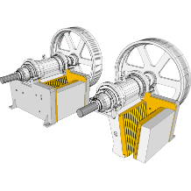

Jaw crushers uses two jaws to crush materials into smaller pieces. The jaws are typically made of steel, but they can wear out over time due to the abrasive nature of the materials being crushed.

The areas of the jaw crusher that are most susceptible to wear are the jaw plates, the toggle plate, and the frame. The jaw plates are the surfaces that come into direct contact with the material being crushed, and they are the most likely to wear out. The toggle plate is the part of the crusher that connects the jaws, and it can also wear out due to the forces exerted on it. The frame is the structure that supports the jaws and the toggle plate, and it can also wear out over time.

Abrasion resistant steel is a type of steel that is specifically designed to resist wear and tear. It is often used in the construction of jaw crusher components, such as jaw plates, toggle plates, and frames. The use of abrasion resistant steel in jaw crushers can significantly improve the lifespan of these components. In some cases, the service life of jaw crushers can be doubled by using abrasion resistant steel.

In addition to increasing the lifespan of jaw crusher components, abrasion resistant steel can also improve the performance of the crusher. Abrasion resistant steel is harder than regular steel, which means that it can withstand more wear and tear without breaking. This can lead to a more efficient crushing process and a better product output. Overall, the use of abrasion resistant steel in jaw crushers is a cost-effective way to improve the performance and lifespan of these machines.

**Grades:** AR400 or AR500 steel can also be used in jaw crushers. These steel grades are also known for their high strength and toughness, which can withstand the high compressive forces generated by jaw crushers.

**F. Sorting Screens: Sustaining Screening Efficiency**

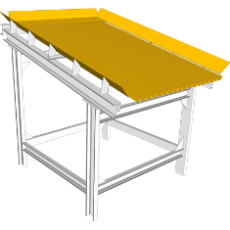

Sorting screens are used to separate materials of different sizes or densities.

The challenges faced by sorting screens include:

1. Abrasion from the materials being screened
2. Corrosion from the environment
3. Deformation from the forces exerted on the screen

The operational lifespan of sorting screens can be extended by using abrasion resistant steel. Abrasion resistant steel is a type of steel that is specifically designed to resist wear and tear. It is often used in the construction of the screen mesh, the frame, and the supporting structures. The use of abrasion resistant steel in sorting screens can significantly improve their lifespan. In some cases, the service life of sorting screens can be doubled by using abrasion resistant steel.

In addition to extending the lifespan of sorting screens, abrasion resistant steel can also improve their performance. Abrasion resistant steel is harder than regular steel, which means that it can withstand more wear and tear without breaking. This can lead to a more efficient screening process and a better product output. Overall, the use of abrasion resistant steel in sorting screens is a cost-effective way to improve their performance and lifespan.

**Grades:** AR400 or AR500 steel can be used in sorting screens. These steel grades are known for their high strength and toughness, which can withstand the abrasive wear generated by the materials being screened.

**G. Gyratory Crushers: Enhancing Crushing Apparatus Longevity**

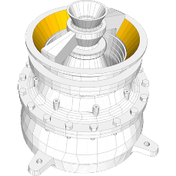

Gyratory crushers play a pivotal role by converting sizable rocks into smaller particles amenable for further processing. Acting as primary crushers, they constitute the initial phase of material reduction in mining operations. The liners, encompassing the interior of the gyratory crusher's crushing chamber, are constructed from steel but are susceptible to gradual wear due to the abrasive properties of the crushed materials.

The adoption of abrasion-resistant steel liners has marked a significant stride in bolstering the operational lifespan of gyratory crushers. Characterized by its resistance to wear and damage, abrasion-resistant steel is purpose-engineered to endure tough conditions. Its elevated hardness compared to regular steel confers the ability to withstand increased wear and tear without succumbing to fractures. This advancement translates to amplified operational uptime and diminished maintenance expenses for gyratory crushers. Furthermore, the deployment of abrasion-resistant liners enhances the product quality, as the sturdy liners are less prone to inflicting harm upon the materials being crushed. Beyond augmenting the service life, these resilient liners contribute to the safety aspect of gyratory crushers. The inherent durability of abrasion-resistant steel curbs the likelihood of cracks or breakages, thereby reducing potential harm to machine operators. This evolution towards abrasion-resistant steel liners has reverberated positively in the mining sector, enhancing the efficacy, endurance, and safety of gyratory crushers, thereby augmenting productivity and profitability across mining operations.

**Grades:** AR400 or AR500 steel can be used in gyratory crushers. These steel grades are known for their high strength and toughness, which can withstand the high compressive forces generated by gyratory crushers.

**H. Screw Conveyors: Increasing Material Transport Reliability**

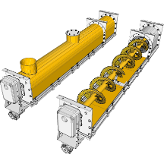

Primarily designed to transfer materials from one location to another, screw conveyors demonstrate the capability to handle an array of substances, encompassing solids, liquids, and slurries. However, these conveyors are not immune to the wear and tear incurred from the materials they transport, especially in instances where the conveyed materials are abrasive in nature.

The integration of abrasion-resistant steel emerges as a pragmatic approach to prolonging the operational life of screw conveyors. This specialized steel variant is meticulously engineered to counteract wear and damage, characterized by its heightened hardness compared to standard steel. As a consequence, abrasion-resistant steel confers enhanced endurance against wear and tear, effectively minimizing the risk of component fractures or deterioration. The adoption of abrasion-resistant steel yields a host of advantages, encompassing a lengthened service life of the screw and its associated components, leading to substantial cost savings by diminishing the frequency of repairs and replacements. Moreover, this integration curtails the necessity for frequent maintenance, given the prolonged durability of the components. These enhancements collectively culminate in an elevated operational efficiency, with reduced material resistance during transportation. Additionally, the implementation of abrasion-resistant steel enhances safety by minimizing the probability of untimely breakdowns or malfunctions, consequently mitigating potential hazards. In essence, the strategic utilization of abrasion-resistant steel in screw conveyors effectively extends their lifespan, heightens performance, and augments the safety aspects, constituting a judicious investment in improving these machines.

**Grades:** AR400 or AR500 steel can be used in screw conveyors. These steel grades are known for their high strength and toughness, which can withstand the abrasive wear generated by the materials being conveyed.

**I. Conveyors: Durability in Material Distribution**

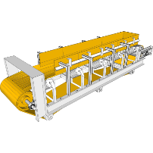

Conveyors stand as vital pillars within material handling systems, facilitating the seamless transfer of materials from one location to another. Their ubiquity spans a diverse range of industries, including manufacturing, warehousing, and distribution.

However, the very materials they transport can instigate wear and tear on conveyors over time, particularly when those materials possess abrasive characteristics. In response to this challenge, abrasion-resistant steel emerges as a tailored solution, meticulously engineered to withstand the rigors of wear and tear. This specialized steel variant finds purposeful integration in the fabrication of key conveyor components, including belts, rollers, and chutes.

The incorporation of abrasion-resistant steel in conveyors substantially augments their operational longevity. In certain scenarios, the utilization of this steel variant has been observed to double the service life of conveyors, signifying a remarkable enhancement in their durability. Beyond lifespan extension, abrasion-resistant steel confers performance benefits. With its elevated hardness relative to standard steel, it can endure more wear and tear without succumbing to fracture. This heightened resilience translates to improved efficiency within the material handling process.

In summation, the deployment of abrasion-resistant steel in conveyors constitutes a pragmatic and cost-effective strategy for amplifying both their performance and longevity.

**Grades:** AR400 or AR500 steel can also be used in conveyors. These steel grades are also known for their high strength and toughness, which can withstand the abrasive wear generated by the materials being conveyed.

**J. Chutes and Hoppers: Resilience in High-Impact Environments**

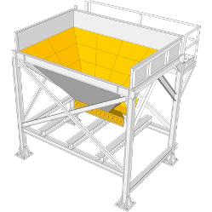

Chutes and hoppers play pivotal roles within material handling systems, facilitating the movement of materials between locations in various industries like mining, construction, and manufacturing. In rigorous high-impact settings, chutes and hoppers bear the brunt of substantial wear and tear. The materials they convey can possess abrasive qualities, while the components themselves also endure impact and shock forces.

By integrating abrasion-resistant steel into chutes and hoppers, their operational lifespan can witness significant extension. In certain instances, the service life of these components can even double with the adoption of abrasion-resistant steel. This steel type not only enhances longevity but also contributes to enhanced performance. Its hardness surpasses that of conventional steel, enabling it to endure greater wear and tear without succumbing to fractures. This elevated robustness translates to improved efficiency in material handling processes. The strategic use of abrasion-resistant steel within chutes and hoppers proves an economical way to amplify both their performance and longevity.

To delve further, the materials transported, like sand and gravel, can be highly abrasive, hastening the wear of chutes and hoppers. Additionally, these components are subjected to impact and shock during loading and unloading, potentially compromising their integrity. Abrasion-resistant steel not only combats abrasion but also fortifies against impact damage, ensuring the components remain robust. In conclusion, abrasion-resistant steel emerges as a crucial asset in enhancing the endurance and performance of chutes and hoppers within high-impact environments, offering a suite of benefits.

Here are some of the specific ways that abrasion resistant steel can protect chutes and hoppers in high-impact environments:

1. It can help to prevent the chutes and hoppers from wearing out from the abrasive materials being transported.
2. It can help to prevent the chutes and hoppers from being damaged from impact and shock.
3. It can help to keep the chutes and hoppers in good condition, which can lead to a more efficient material handling process.

**Grades:** AR400 or AR500 steel can be used in chutes and hoppers. These steel grades are known for their high strength and toughness, which can withstand the impact forces generated by the materials being conveyed.

**K. Log Washers: Tackling Tough Contaminants**

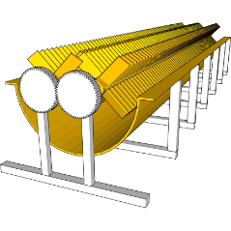

Log washers, integral to various industries including timber, pulp and paper, and mining, employ water and rotating paddles to effectively cleanse logs. The core purpose of log washers revolves around expunging contaminants from logs, such as dirt, bark, and debris. This step is crucial to ensure that the logs are devoid of impurities before undergoing further processing. Operating log washers can be intricate due to the presence of these contaminants, some of which are abrasive, leading to gradual wear and tear of the machine components.

To address this challenge, the incorporation of abrasion-resistant steel proves instrumental. Tailored to counter wear and tear, this steel variant is frequently utilized in constructing log washer components like paddles and housing. By integrating abrasion-resistant steel into log washers, their operational longevity can witness a substantial boost. In select cases, the utilization of this steel can even double the machine's service life. Beyond enhancing longevity, the inclusion of abrasion-resistant steel also augments performance. Its innate hardness surpasses that of standard steel, enabling it to endure increased wear and tear without fracturing. This resilience translates into an efficient log washing process. In essence, integrating abrasion-resistant steel into log washers emerges as a cost-effective method to enhance their performance and extend their operational lifespan.

Further insights elucidate the challenges posed by contaminants, some of which can be highly abrasive, such as sand and gravel, hastening component wear. Additionally, the presence of corrosive contaminants, often encountered in mining, further jeopardizes the components. In both cases, abrasion-resistant steel offers a formidable solution. Characterized by its robustness, this steel type withstands the demanding conditions inherent to log washer operation. Notably, its cost-effectiveness adds to its allure, providing a pragmatic avenue to prolong the life of log washer equipment.

Here are some of the specific ways that abrasion resistant steel can protect log washers from contaminants:

1. It can help to prevent the log washer components from wearing out from the abrasive contaminants.
2. It can help to prevent the log washer components from being damaged from corrosion.
3. It can help to keep the log washer components in good condition, which can lead to a more efficient log washing process.

**Grades:** AR400 or AR500 steel can be used in log washers. These steel grades are known for their high strength and toughness, which can withstand the abrasive wear generated by the logs being washed.

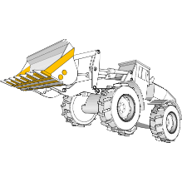**L. Buckets: Strengthening Load-Bearing Components**

Buckets play a pivotal role as indispensable components within load handling equipment, facilitating the efficient transportation of materials across industries ranging from construction and mining to agriculture. In the demanding scope of their operation, buckets encounter considerable wear and tear as a result of the materials they transport. These materials often exhibit abrasive characteristics, and the buckets themselves are exposed to the jarring impact and shock of their work environment.

To counteract these challenges, the application of abrasion-resistant steel emerges as a specialized solution. Designed to withstand wear and damage, this type of steel finds practical integration in the construction of bucket components, including bucket teeth, lining, and the frame. The incorporation of abrasion-resistant steel into bucket components yields substantial enhancements in operational longevity. In specific instances, the utilization of this steel variant has shown the potential to double the lifespan of buckets. Beyond longevity, the adoption of abrasion-resistant steel translates into performance benefits. Its inherent hardness surpasses that of conventional steel, empowering it to endure heightened wear and tear without succumbing to fractures. This increased resilience in turn fosters a more efficient process of load handling. In sum, the strategic utilization of abrasion-resistant steel within bucket components presents a cost-effective avenue to elevate their performance and extend their operational lifespan.

Further insight highlights the challenges arising from wear and tear on bucket components, particularly from abrasive materials like sand and gravel. This accelerated deterioration affects critical parts like bucket teeth and lining. Additionally, buckets often face impact and shock during loading and unloading, further compromising the integrity of their components. Abrasion-resistant steel proves effective in addressing these challenges, offering robustness that withstands the demanding conditions of bucket operations. Its relatively affordable nature enhances its appeal, providing a pragmatic method to prolong the lifespan of bucket equipment.

Here are some of the specific ways that abrasion resistant steel can protect bucket components:

1. It can help to prevent the bucket teeth and the bucket lining from wearing out from the abrasive materials being transported.
2. It can help to prevent the bucket components from being damaged from impact and shock.
3. It can help to keep the bucket components in good condition, which can lead to a more efficient load handling process.

**Grades:** AR400 or AR500 steel can also be used in buckets. These steel grades are also known for their high strength and toughness, which can withstand the impact forces generated by the materials being handled.

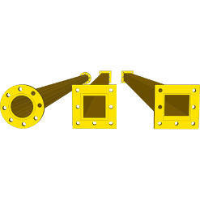**M. Slurry Pipelines: Ensuring Efficiency in Material Transport**

Slurry pipelines play a pivotal role in transporting materials existing in a slurry state, wherein substances are suspended within a liquid medium like water or oil. These pipelines are of paramount significance across industries encompassing mining, construction, and waste management. The central function of slurry pipelines is to facilitate the seamless and efficient movement of materials between different locations. These pipelines cater to the transportation needs of a diverse range of materials, including coal, ore, sand, and gravel, optimizing the process of material conveyance. Operating slurry pipelines presents challenges stemming from the abrasive nature of the transported materials. The constant interaction between the materials and the pipeline walls can lead to gradual wear, potentially resulting in leaks and other operational issues.

To tackle this challenge head-on, the integration of abrasion-resistant steel emerges as an effective solution. Specifically designed to withstand wear and tear, this type of steel finds its application in the construction of slurry pipelines, encompassing components like pipe walls and fittings. The incorporation of abrasion-resistant steel into slurry pipelines engenders a significant extension in their operational lifespan. In certain cases, these pipelines' service life can even be doubled through the utilization of this robust steel variant. Beyond longevity, the adoption of abrasion-resistant steel translates into performance enhancements. Its elevated hardness equips it to withstand heightened wear and tear without succumbing to breakage, culminating in a more efficient process of slurry transportation. In summation, the strategic employment of abrasion-resistant steel within slurry pipelines emerges as a cost-effective avenue to elevate their performance and prolong their operational life.

Additional insights shed light on challenges arising from the abrasive nature and low pH levels of materials. Materials like sand and gravel, known for their abrasive properties, can lead to swift wear of pipeline walls. Moreover, the materials' acidity can trigger corrosive effects on the pipeline walls. Abrasion-resistant steel effectively addresses these formidable challenges, as it possesses the strength and durability necessary to endure the demanding conditions of slurry pipeline operations. Moreover, its cost-effectiveness adds a practical dimension to the equation, presenting a viable strategy to extend the lifespan of slurry pipeline equipment.

Here are some of the specific ways that abrasion resistant steel can protect slurry pipelines:

1. It can help to prevent the pipeline walls from wearing away from the abrasive materials.
2. It can help to prevent the pipeline walls from corroding from the acidic materials being transported.
3. It can help to keep the pipeline walls in good condition, which can lead to a more efficient slurry transportation process.

**Grades:** AR400 or AR500 steel can be used in slurry pipelines. These steel grades are known for their high strength and toughness, which can withstand the abrasive wear generated by the slurry being conveyed.

**N. Drill Rigs: Superior Tubes for Lasting Performance**

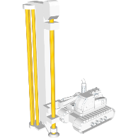

Drill rigs constitute pivotal machinery within the mining industry, serving the crucial function of boring holes into the ground to facilitate ore extraction. Given the demanding nature of their operation, drill rigs encounter substantial wear and tear, with drill tubes emerging as a paramount component. At the core of drill rigs, the drill tubes bear direct contact with the ground. While constructed from steel, these tubes gradually succumb to wear due to the abrasive nature of the terrain.

Incorporating AR400 or AR500 drill tubes holds the potential to substantially augment the operational lifespan of drill rigs. In certain scenarios, the utilization of these specialized tubes can double the longevity of the drill rigs. Beyond longevity, abrasion-resistant steel confers performance enhancements to drill tubes. Notably harder than standard steel, it possesses the capability to endure elevated wear and tear without fracturing, consequently promoting a more efficient drilling process. In sum, the strategic integration of abrasion-resistant steel within drill tubes emerges as a cost-effective avenue to elevate their performance and extend their operational lifespan.

Here are some other benefits of using abrasion resistant steel in drill tubes:

1. They can help to improve the quality of the drilled holes.
2. They can help to reduce the risk of accidents.
3. They can help to improve the overall performance of the drill rig.

**Grades:** AR400 or AR500 steel can be used in drill rigs. These steel grades are known for their high strength and toughness, which can withstand the impact forces generated by the drill bit.

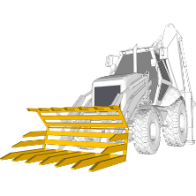**O. Forklift Arms: Enhancing Payload Handling**

Forklift arms hold an indispensable role within the realm of forklift machinery. Deployed across diverse industries including manufacturing, warehousing, and construction, these arms serve the pivotal function of elevating and transporting materials. The fundamental purpose of forklift arms in the domain of load handling is to ensure the secure and efficient lifting and relocation of materials. This versatile component caters to a wide array of materials, ranging from boxes and pallets to even vehicles. Enduring constant engagement in lifting and relocation activities, forklift arms bear a substantial degree of wear and tear. Notably among the most critical constituents of a forklift, they undergo ceaseless usage to transport materials and stand exposed to environmental elements.

To address these formidable challenges, the integration of abrasion-resistant steel (AR steel) emerges as an impactful solution to amplify the lifespan of forklift arms. Tailored to resist wear and tear, AR steel finds application in the construction of various forklift arm components, encompassing forks and booms. The incorporation of AR steel within forklift arms leads to a significant elevation in their operational longevity. Notably, in certain scenarios, the deployment of AR steel can usher in a doubling of the forklift arms' service life. Furthermore, AR steel augments the performance of forklift arms. Distinguished by its hardness surpassing that of standard steel, it boasts the resilience to withstand heightened wear and tear without succumbing to breakage. This elevated resilience consequently fosters a more efficient process of load handling. In summation, harnessing the potential of AR steel within forklift arms presents a cost-effective avenue to amplify their performance and prolong their operational lifespan.

Here are some other benefits of using AR steel in forklift arms:

1. It can help to prevent the forks and the boom from wearing out from the constant use.
2. It can help to prevent the forks and the boom from corroding from exposure to the elements.
3. It can help to keep the forks and the boom in good condition, which can lead to a more efficient load handling process.
4. It can help to reduce the weight of the forklift, which can improve fuel efficiency.
5. It can help to increase the payload capacity of the forklift, which can improve productivity.
6. It can help to improve the safety of the forklift, as they are less likely to fail.

**Grades:** AR400 or AR500 steel can also be used in forklift arms. These steel grades are also known for their high strength and toughness, which can withstand the impact forces generated by the materials being lifted.